Carbon Monoxide Awareness
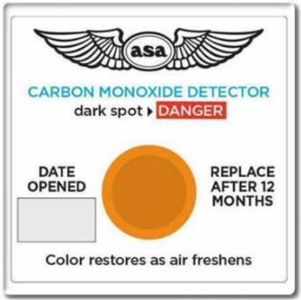
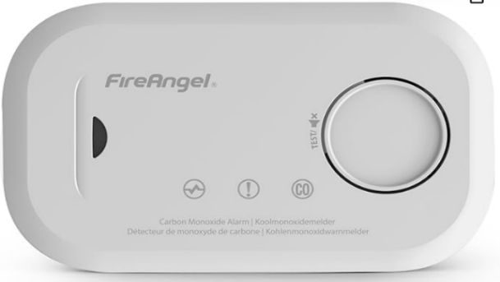
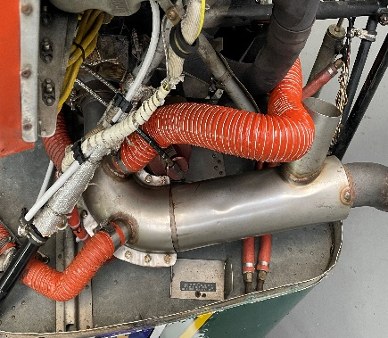
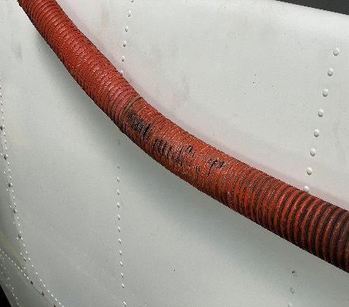
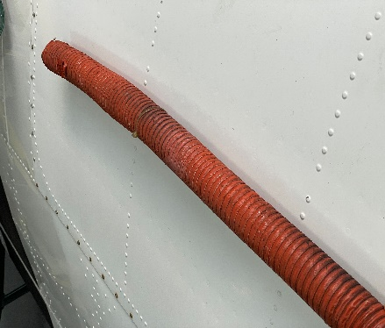
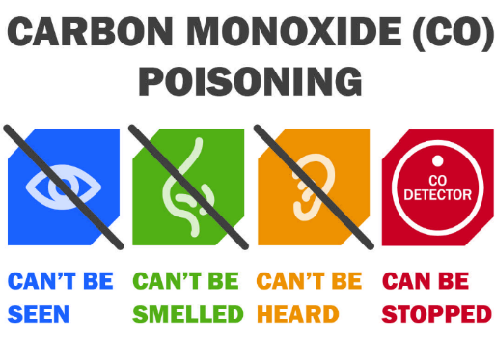
Carbon monoxide (CO) is a poisonous, flammable gas that is colourless, odourless, tasteless, and slightly less dense than air. CO consists of one carbon atom and one oxygen atom connected by a triple bond. The most common source of carbon monoxide is the combustion of carbon-containing compounds.
Further Inspection
CO Detectors - Can be purchased from either online stores, supermarkets or aviation shops. The 3 detectors below are common throughout general aviation from stickers, battery power and car light plug. All varying in price, design. The CAA recommend that pilots fly with a CO detector in the aircraft that is capable of providing audible/visible warnings that actively engage a pilot’s attention when pre-determined carbon monoxide levels are exceeded typically 50 parts per million. As CO is slightly less dense than air it will rise, so think where is best to place the detector. Ideally line of sight of the pilot should the detector activate.
New Hose Installed
Found Unserviceable
Initial Inspection
Case Study – Whilst carrying out an annual inspection, a scat hoses in a PA28 engine bay appeared to be serviceable from an initial view. As the inspection continued the other side of the scat hose appeared to have several holes running along it. If the hose wasn’t changed and there was an exhaust leak then the carbon monoxide would have entered the cabin through the heating system, leading to sever consequences. This is why it is vital to ensure correct maintenance inspections are carried out. As pilots do the A check, do they always look around the scat hoses….. Pictures detailed below.
Why is it important in aviation? - Carbon monoxide poisoning has been cited as a factor in multiple GA accidents globally. The physiological effects of CO poisoning are cumulative and take a very long time to disperse. Even a low level of CO ingestion, below the level that causes immediate physical symptoms, will cause a progressive reduction in blood oxygen levels which will reduce pilot performance and potentially lead to aviation incidents.

